Sonja Mejcher-Atassi

Abdelké, Youssef (1951--Present) Word Count: 585

Abdelké was born in Qameshli, Syria, in 1951. He graduated from the Faculty of Fine Arts in Damascus in 1976. Politically active as a member in the League of Communist Action, later renamed the Communist Labor Party and banned by the Syrian regime, he was imprisoned for two years, then left for France where he continued his studies. He graduated with a diploma in etching from the École Nationale Supérieure des Beaux Arts in Paris in 1986, and obtained a PhD in Plastic Arts from the University VIII in Paris in 1989. Abdelké was arrested anew in July 2013 but released after five weeks. After more than twenty-five years in exile, he returned to Damascus in 2005, where he continues to live and work today.

Abdelké gives preference to drawing over painting. He has worked in different media but has mainly focused on charcoals on paper. His charcoal works show still lives such as flowers, dead fish and birds, and fruit; and everyday objects, such as shoes, teapots, plates, and knives, with which he expresses human tragedy in manifold ways. Closely linked to aesthetic concerns, his subjects explore in basic media, charcoal and paper, dimensions of art that have been neglected with the introduction of Western techniques—namely perspective—into modern artistic practices in the Arab world. They draw on concepts of one-dimensionality and the flat surface, as they dominated Islamic miniature painting.

Even still lifes of dead objects acquire a political notion in Abdelké’s work, as his nailed down flowers, tied up fish, dead birds, and gigantic raised fists show. The political has again come to the fore in his recent work, produced since the Syrian uprising of 2011, which was shown in his solo exhibition at Tanit Gallery in Beirut in February 2014. It features portraits of martyrs from Daraa, Homs, Damascus and other cities across Syria but also still lives: the familiar flowers and teapots, now stained with red colour dripping down the picture plane.

Abdeldké is also known for his caricatures, published in Arabic journals and newspapers, such as *al-Nahar*, *al-Quds*, and *al-Khalij,* which give voice to political ideas in very direct ways. So do his etchings of political personages produced in the early 1990s. Abdelké has a profound interest in graphic design. He produced many posters, logos, and book covers in addition to more than thirty children books. He has also researched caricature in the Arab world, especially in Syria, and has written two studies on the topic. Abdelké has been a respected and critical voice in the art world since the 1970s. In his article “Aqd min al-qarn al-jadid fi thaqafatina: Fann  
bila hudud,” (“A New Era in Our Culture: Art without Borders”), published in the Lebanese daily *al-Safir* in 2010, he credits Arab artists for having resisted “the power of dictatorship” but questions their capacity to withstand “the power of capital.” The article has triggered heated debate.

Abdelké had his first solo exhibition in al-Huriyya Hall in Damascus in 1973. More solo exhibitions followed in Damascus, Cairo, Tunis, Amman, Beirut, Dubai, Manama, Paris, Alexandria, Kuwait, Homs, and Helsinki. He also participated in international biennales, such as the Sharjah Biennale in 1995 and the Art Paris Art Fair in 2014, and in numerous group exhibitions in the Arab world as well as abroad. His work is held in private and public collections, among them the Institut du Monde Arabe, Paris; the British Museum, London; the Jordan National Gallery of Fine Arts, Amman; and the National Museum, Kuwait.

Image:

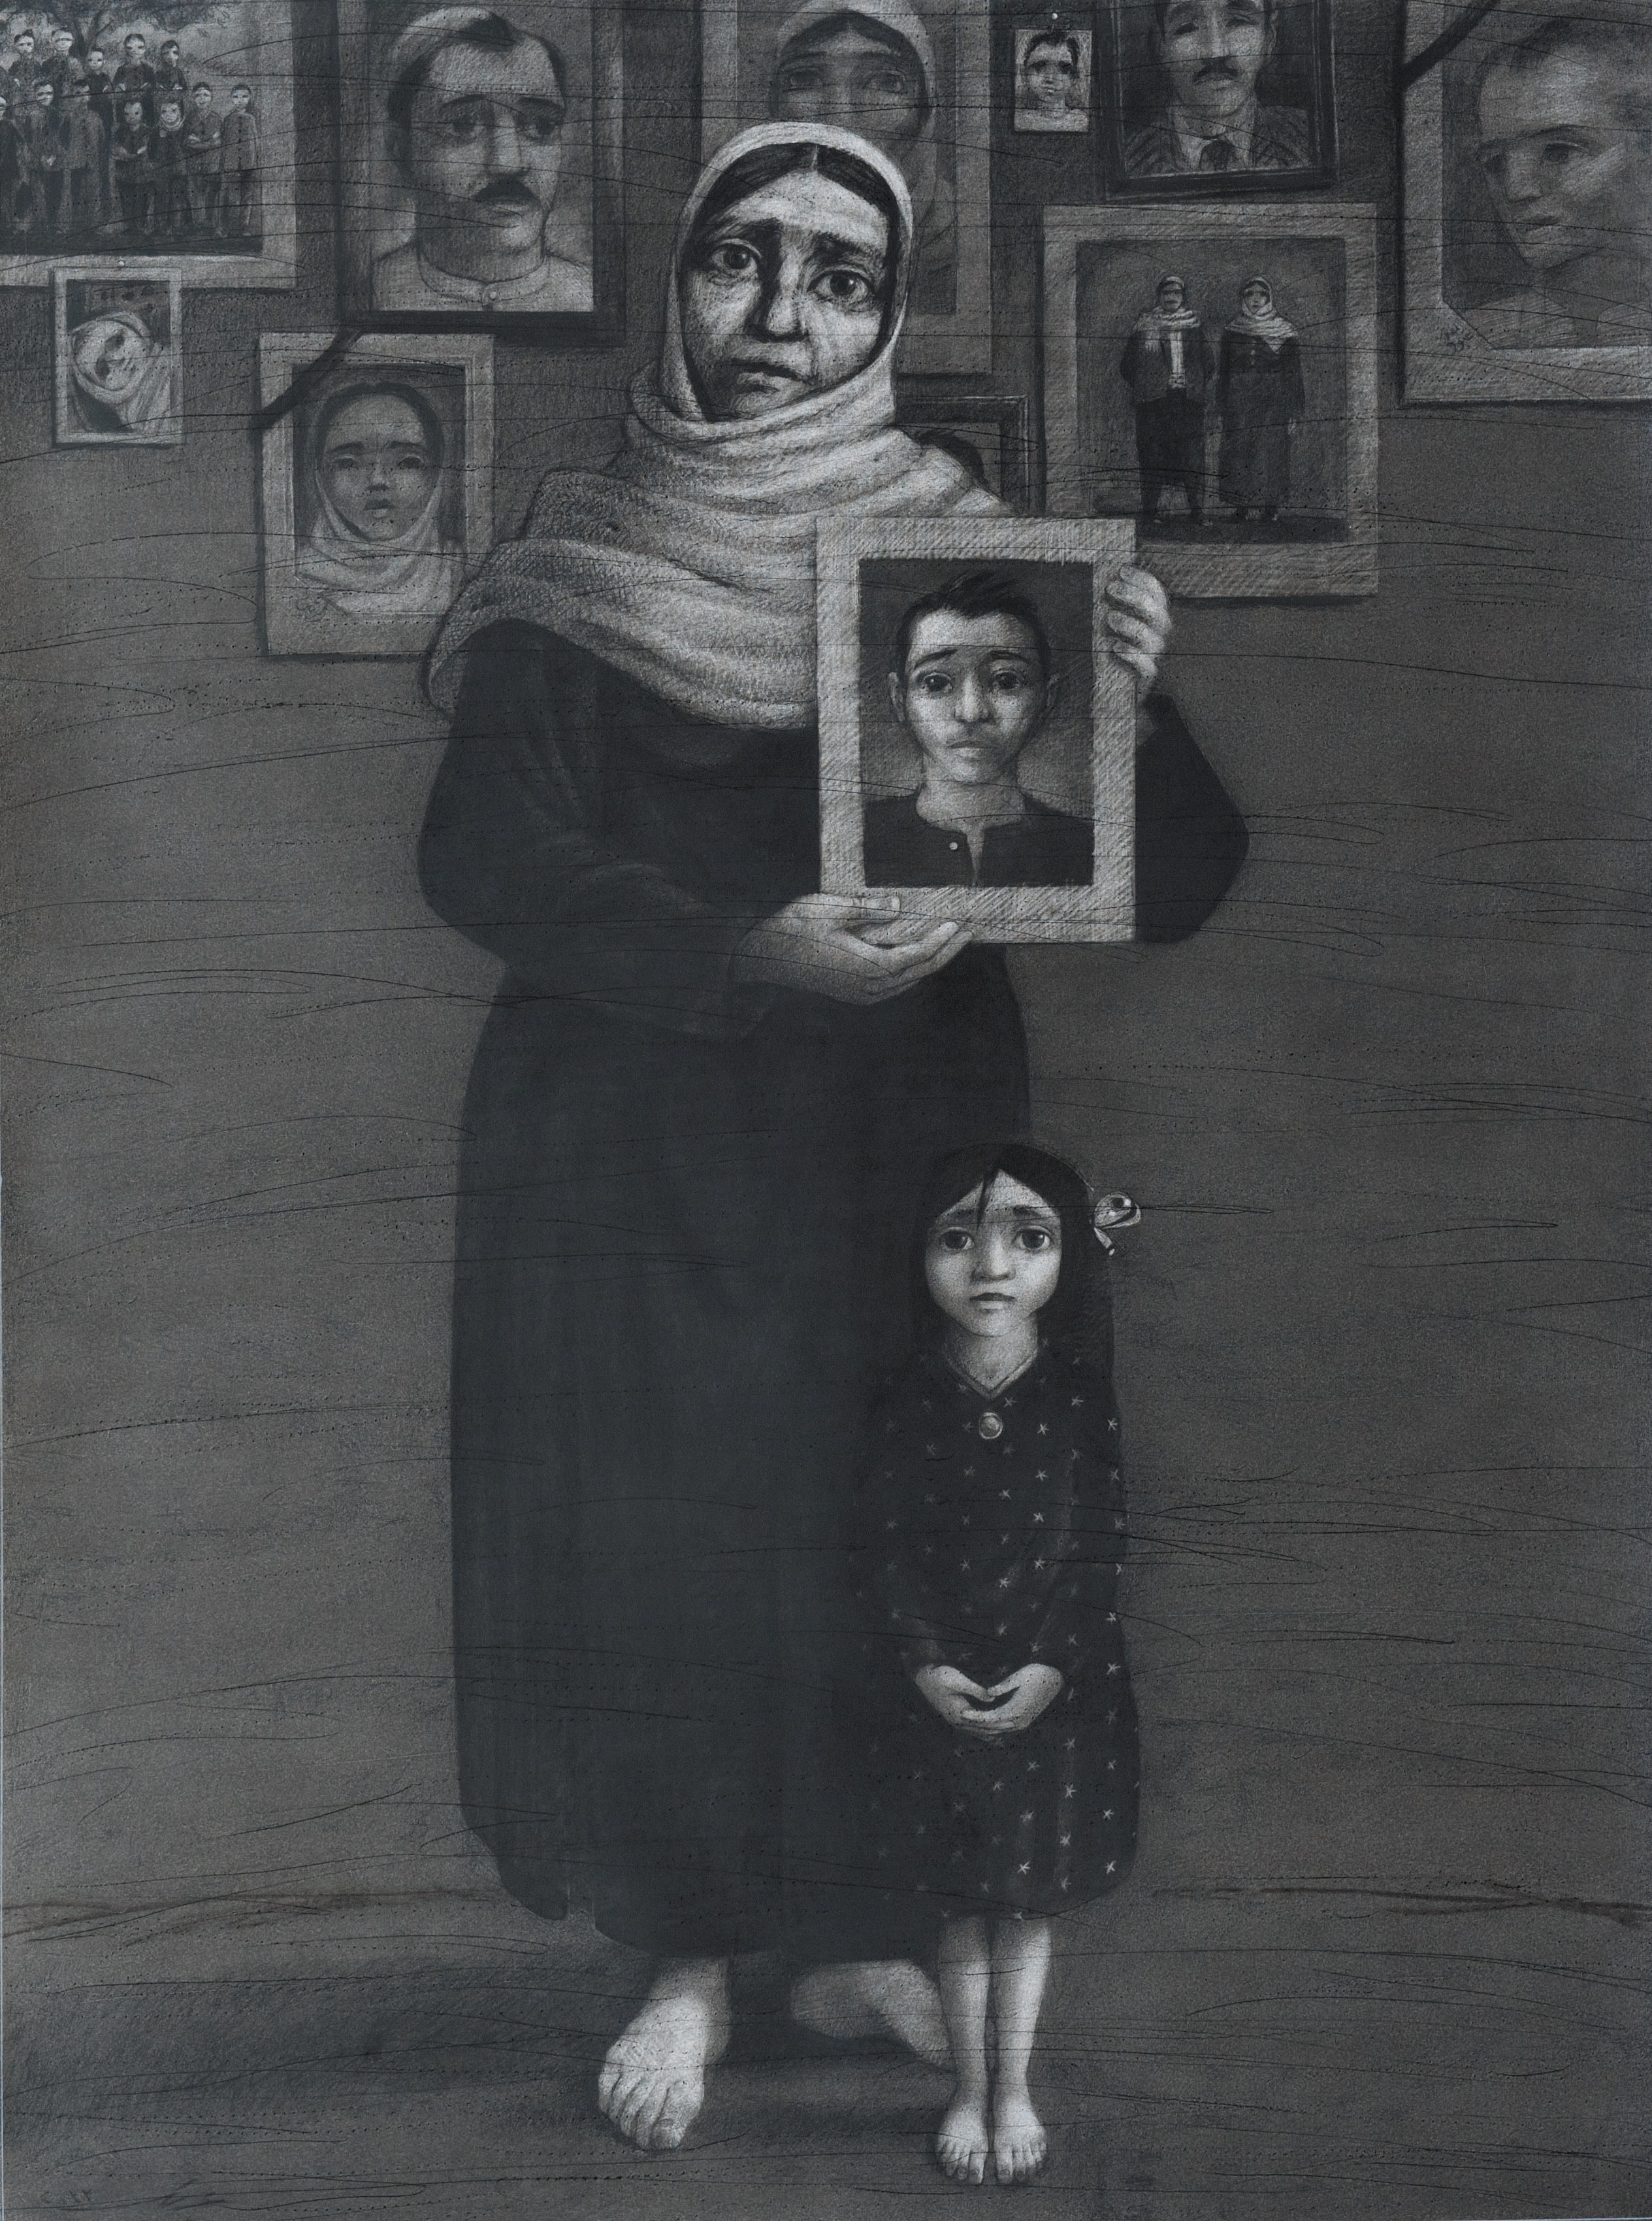

*Um al-shahid / Mother of the Martyr*, charcoal on paper, 194 x 145 cm, 2012.

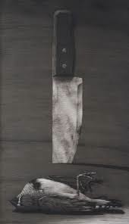

*Sakin was ‘asfur / Knife and Bird*, charcoal on paper, 248 x 146 cm, 2010.

References and further reading (selection):

Gonzales, Yves (2010) “Un art sans frontières? L’art arabe face au marché global,” http://cpa.hypotheses.org/2037, and http://cpa.hypotheses. org/2052.

Menhem, Emil (2007) “al-Ashiya’ that sahr al-dalala (Things under the Magic of Significance),” in *Abdelke*, Damascus: Ayyam Gallery, 191-198.

Nazih Abu ‘Afash (2005), “Yusuf Abdelke wa-hulm al-hayat al-maqtu’” (Youssef Abdelke and The cut dream of life), Damascus: Atassi Gallery, 2005, 9-15.

Youssef Abdelké’s writings on art (selection):

*Tarikh al-karikatir fi Suriya* (History of Caricature in Syria), 1975.

*Rasami al-karikatir al-‘arab wa-taqniyatihim* (Arab Caricaturists and Their Techniques), 1989.

“‘Aqd min al-qarn al-jadid fi thaqafatina: Fann  
bila hudud” (A New Era in Our Culture: Art without Borders), *al-Safir,* no. 11480, 29.12.2009.